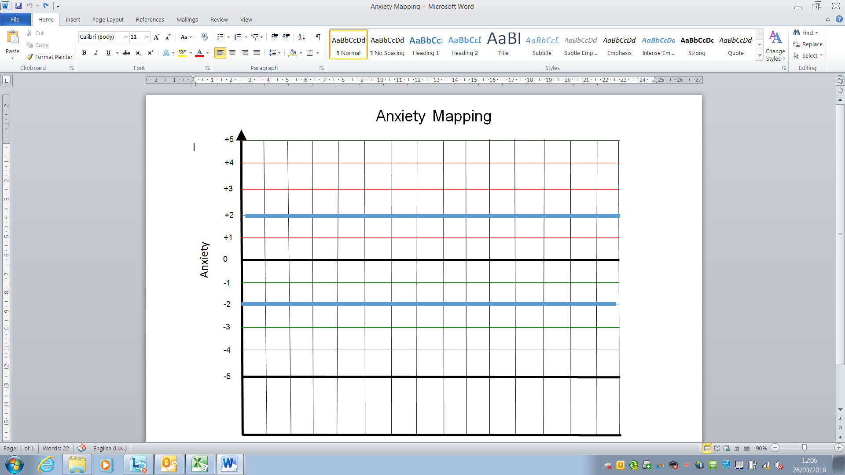
Dependency self-managed
Their anxiety affects their behaviour
Their anxiety and behaviour affects others
Their behaviour becomes dangerous
Overly dependent
Overwhelmed
If withdrawn their anxiety affects their behaviour
If withdrawn their anxiety and behaviour affects others
If withdrawn their behaviour becomes dangerous
Needs no support to manage their anxiety and behaviour
Staff, location, activity, peers, days etc
(Each area above should be mapped on a separate form to cross reference these and identify multiple rises in anxiety)
Anxiety self-managed
Anxiety Mapping Guidance
By tracking staff, location, activity, peers, days etc. against the student’s anxiety we can manage the anxiety based feelings that creates difficult and dangerous behaviours. By completing a variety of anxiety maps we can then cross reference these to identify multiple high anxieties such as a certain adult, who is leading an activity at a certain time meaning it is likely that these 3 rises will result in the pupil being unable to cope.
Anxiety mapping is a tool used over time to collect information to be analysed to understand the feelings and experiences effecting the child or young person. The aim is to predict escalation and prevent it through differentiation or support. They are best completed over at least a week of observation and discussion to ensure the grid is an accurate reflection of the stimulus.
 | Score | Description
Raised Anxiety | +2 to + 5 | Reflects raised anxiety where the individual would need support, differentiation and help to change or manage the experience or feelings. If there was no support offered the individual would begin to display behaviour that may be linked with feeling overwhelmed or being unable to process without assistance
Raised Anxiety | 0 to + 2 | Would reflect a raise in anxiety that the individual could cope with without needing assistance or differentiation.
 | 0 | Would reflect that the time, location, staff or activity has no impact on the individual
Increased dependency | 0 to – 2 | Would reflect lower anxiety where the individual feels calm, reflective and motivated linked to time, location, adult or activity.
Increased dependency | -2 to -5 | Reflects an overwhelming reliance or an object, person or place and without this the child would be unable to manage their feelings or behaviours until this was returned

Each child or young person’s -5 to + 5 would be specific and observable to them and their behaviour.

Raising anxiety is essential for some elements of education. Without raised anxiety students would not attempt new things or experience new opportunities essential to learn and grow.

